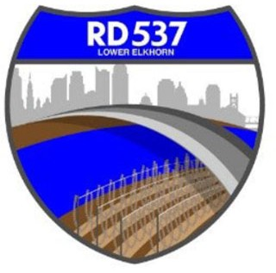NOTICE OF MEETING AND AGENDA RECLAMATION DISTRICT NO. 537

The Board of Trustees of Reclamation District No. 537 has called a special board meeting to be held at **9:00 a.m.** on **Friday, January 24, 2025**. This meeting is open to the public. Members of the public may attend this meeting in person at 889 Drever Street West Sacramento 95691or participate remotely, using the following information:

* Online, via Microsoft Teams at [bit.ly/4g6PBfW](https://bit.ly/4g6PBfW)
* By phone, at 1-916-538-7032; Conference ID: 445068903

During this period of modified Brown Act requirements, RD 537 will use best efforts to swiftly resolve requests for reasonable modifications or accommodations with individuals with disabilities, consistent with the Americans with Disabilities Act, and resolving any doubt whatsoever in favor of accessibility. If you need a disability related modification or accommodation to participate in this meeting, then please call Billy Mattos at (916) 531-1199 or rd537elkhorn@gmail.com. Requests must be made as early as possible, and at least one full business day before the start of the meeting.

# AGENDA

**Call to Order**

1. Meeting attendance/introductions
2. Approval of agenda

# Public Comment on Non-Agenda Items

# Business/Action Items

1. Discussion of Corporation Yard Bids

# Informational Items

1. Additional Informational Items/Trustee Comments
2. Adjourn